SAMV71 RC Test Report

rc_input status # Check RC driver
rc_input start -d /dev/ttyS3 # Manual start
listener input_rc # Monitor RC channels
listener manual_control_setpoint # Monitor control input

Flysky Model FSCT-6B with FS-R6B :

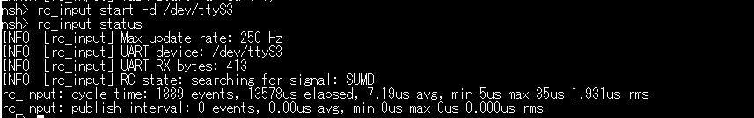

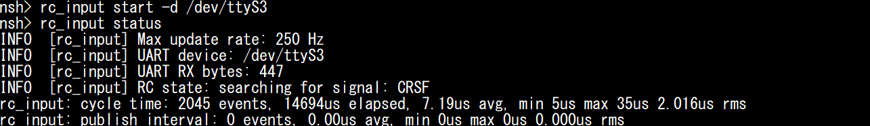

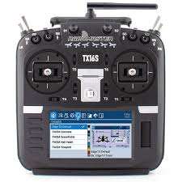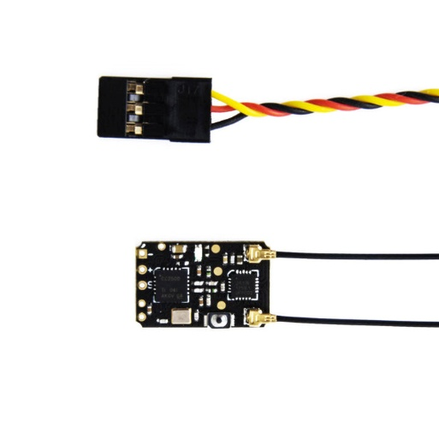

RadioMaster TX16S with R81:

- rc_input start -d /dev/ttyS3
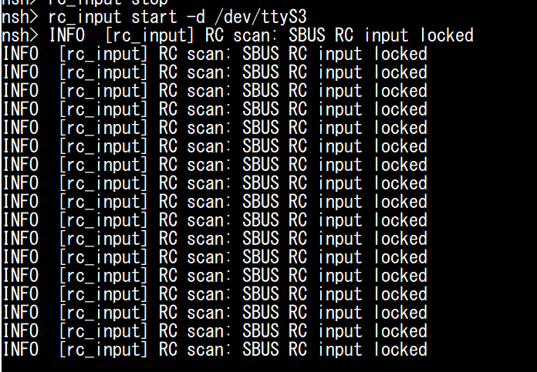

- rc_input status
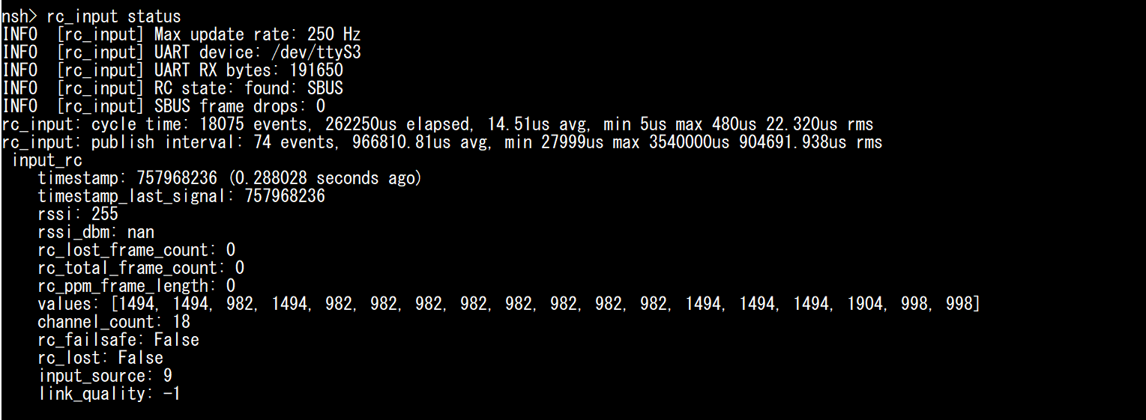

- listener input_rc
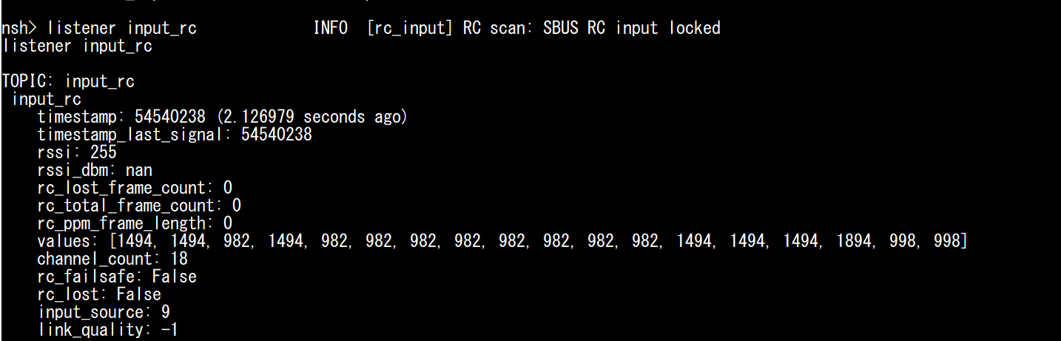

- listener manual_control_setpoint

